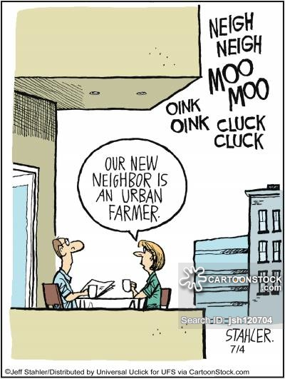
Review Notes for the Agriculture Test!! If you want an A…
Shifting cultivation: using axes and machetes, farmers cut down most of the
tall trees, which normally help bring down the smaller tress. Next the farmers
burn the debris under carefully controlled conditions. Whenever it rains, the
rain comes and washes the fresh ashes into the soil, providing the needed
nutrients.The soil will only be good for 3 years

What is subsistence agriculture?
What are some secondary , primary and tertiary activities?
What are the hearths of agriculture? What crops were first domesticated and where?
Commercial Agriculture?
States of the Corn Belt are Indiana, Illinois, Iowa, Missouri, eastern Nebraska, and eastern Kansas, in which corn (maize) and soybeans are the dominant crops.
Slash and burn(really you cant get what that is yet?), Milpa ( a small field in Mexico or Central America that is cleared from the forest, cropped for a few seasons, and abandoned for a fresh clearing)…swidden.. what is that stuff???
The cleared area, is known as a swidden
1st Ag. Revolution
2nd Ag. Revolution
3rd Ag revolution
Von Thunens rings are
Animals were domesticated first where?
Metes and Bounds, township, long lot are ???
Truck farming vs. Market gardening
Coffee
Mediterranean ag. And climate
Irrigation, salinization,deforestation,desertification, plantation—couldn’t think of more words that ended in ON
Luxury crops
Intensive wet farming.. what the hell is that and why do WE CARE?
First a farmer prepares the field for planting by using a plow drawn by water buffalo or oxen.,The plowed land is then flooded with water. The water is collected from rainfall, river overflow, or irrigation. The flooded field is called a sawah in the Austronesian language of Indonesia. Europeans and North Americans usually call it a paddy, which is the Malay word for wet rice.
The customary way to plant rice is to grow seedlings on dry land in a nursery then transplant the seedlings into the flooded field.
After about a month, they are transferred into the field. Rice plants grow submerged in water for about three--fourths of the growing period and it is usually double cropped..
Intertillage
Water runoff
Carl Sauer
Extensive subsistence agriculture
Feedlot, factory farm, bio fuel
Know your SOUTHEAST ASIA MAP, WORLD REGIONS A CLOSER LOOK MAP..
Read over the 5 steps book Ag. Section and look over the Deblij PPT as well

